**PRACTICAL NO:-9**

**a. Create a web application to demonstrate use of GridView button column and GridView events along with paging and sorting.**

For paging sorting you can define it here after placing gridview.

Now you are able to select as well.

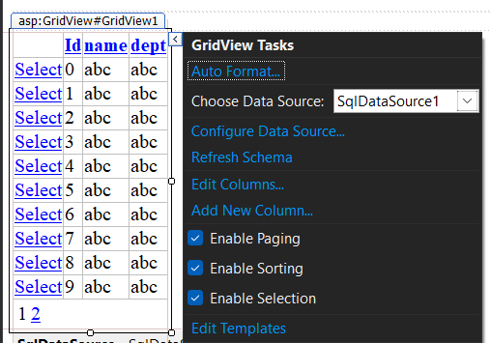

No write code so that if data is choosen then it will able to see on

DetailsView..

**CODE:-**

using System;

using System.Collections.Generic;

using System.Linq;

using System.Web;

using System.Web.UI;

using System.Web.UI.WebControls;

using System.Data;

using System.Data.SqlClient;

namespace db1

{

public partial class prac8a : System.Web.UI.Page

{

protected void Page_Load(object sender, EventArgs e)

{

}

protected void SqlDataSource1_Selecting(object sender, SqlDataSourceSelectingEventArgs e)

{}

protected void GridView1_SelectedIndexChanged(object sender, EventArgs e)

{

GridViewRow rw = GridView1.SelectedRow;

string txt = rw.Cells[1].Text;

int a = Convert.ToInt32(txt);

SqlConnection cn = new SqlConnection(@"Data Source=(LocalDB)\MSSQLLocalDB;AttachDbFilename=C:\Users\karan\source\repos\db1\db1\App_Data\Database1.mdf;Integrated Security=True");

SqlCommand cmd = new SqlCommand("select * from employee where id = '"+ a +"' ",cn);

cn.Open();

SqlDataReader dr = cmd.ExecuteReader();

DetailsView1.DataSource = dr;

DetailsView1.DataBind();

cn.Close();

}

}

}

**OUTPUT:-**

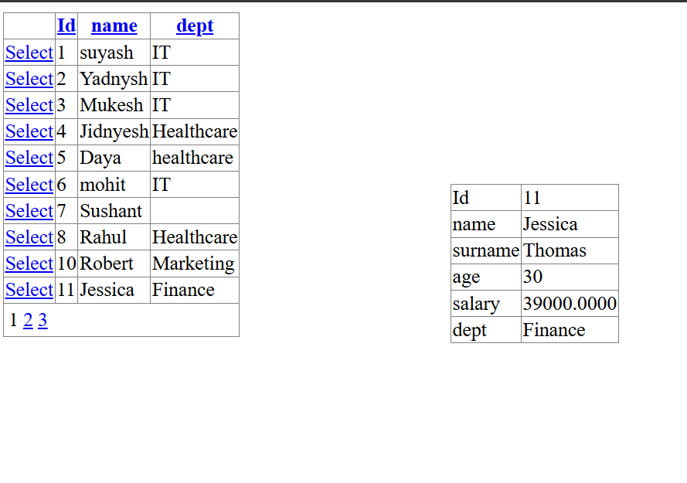

Now data can be sort as well as paging is able here.

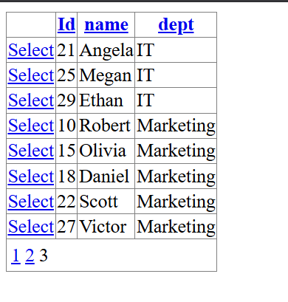

**b. Create a web application to demonstrate data binding using DetailsView and FormView Control.**

For FormView you can set datasource through as below:-

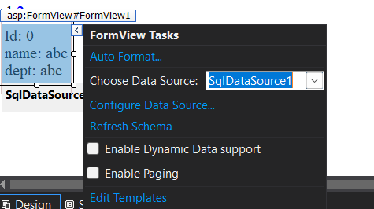

Since it shows only 1 data at a time you can use paging to traverse between multiple records.

You can use various types of templates to display the data

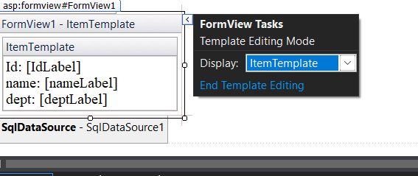

You can use any template.

Here I am choosing item template.

Now use .Autoformat to look better.

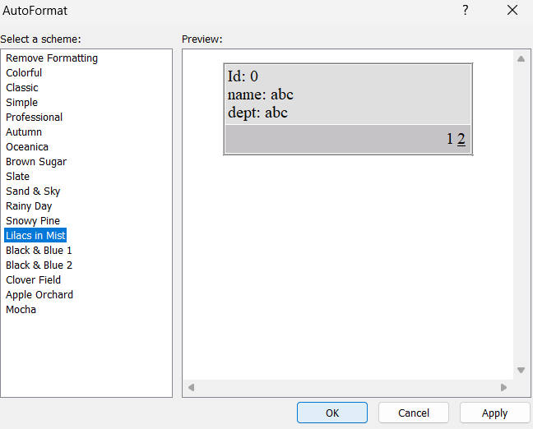

**CODE:-**

protected void GridView1_SelectedIndexChanged(object sender, EventArgs e)

{

GridViewRow rw = GridView1.SelectedRow;

string txt = rw.Cells[1].Text;

int a = Convert.ToInt32(txt);

SqlConnection cn = new SqlConnection(@"Data Source=(LocalDB)\MSSQLLocalDB;AttachDbFilename=C:\Users\karan\source\repos\db1\db1\App_Data\Database1.mdf;Integrated Security=True");

SqlCommand cmd = new SqlCommand("select * from employee where id = '"+ a +"' ",cn);

cn.Open();

SqlDataReader dr = cmd.ExecuteReader();

DetailsView1.DataSource = dr;

DetailsView1.DataBind();

cn.Close();

}

**OUTPUT:-**

